**Network Topologies:**

* Topology is physical layout computers, cables & other components on network
* here are several different network topologies & network may be built using multiple.
* he different types of network layouts are Bus topology, Star topology, Mesh topology.
* There are Ring topology, Hybrid topology, tree topology and Wireless topology & more.
* network topology is the layout of a network, it consists of two parts; physical and logical.
* network Topology, the physical part describes the physical layout of a computer network.
* network Topology, while the logical part describes how the data flows in that network.

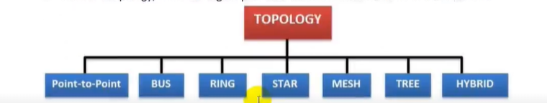

**Bus topology:**

* in IS topology, computers connect through a sing e continuous coaxial cable
* In this bus Topology This coaxial cable is known as the backbone cable of topology.
* Both ends of the backbone cable are terminated through the terminators.
* In Bus Topology to connect a computer to the backbone cable, a drop cable is used.
* To connect drop cable to the computer and backbone cable, the BNC plug and BNC T.
* Cable length required for this topology is the least compared to other networks.
* Easy to set-up & extend bus network, costs very less, less expensive than other topologies.
* Dependency on central cable If main cable some problem, whole network breaks down.
* Security is very low because all the computers receive the sent signal from the source.
* Signal from source is broadcasted and it travels to all workstations connected to bus cable.
* 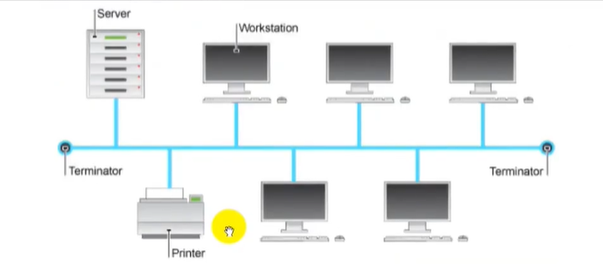In Bus Topology terminator is added at ends of central cable, to prevent bouncing of signals.

**Star Topology:**

* A star topology is designed with each node like workstations, printers, laptops, servers etc.
* In Start topology every end device is directly connected to a central device called switch.
* Each workstation has a cable that goes from its network card to a network switch.
* Most popular & widely used LAN technology Ethernet currently operates in Star Topology.
* Easy to install & wire no disruptions to the network when connecting or removing devices.
* In Start Topology the fault can be easy detect and easy to remove parts from the network.
* If the switch fails, nodes attached are cannot participate in network communication.
* 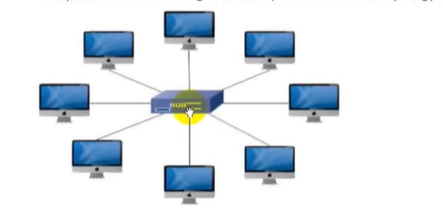Requires more cable length more expensive than bus topology because of Switch cost.

**Mesh Topology:**

* In Mesh topology, every network device is connected to other network devices.
* Mesh topology is costly because of the extra cables needed and it is very complex.
* The main advantage of mesh topology is multiple paths to the destination computer.
* difficult to manage but If one link is down, have another path to reach the destination.

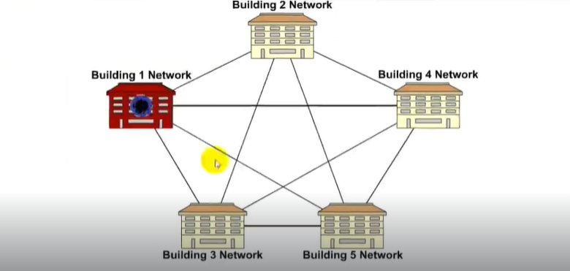

**Hybrid Topology:**

* Hybrid topology is a mixture of different topologies; Example is star-bus-ring topology.
* two networks; one is built from star topology and another is built from the bus topology.
* If connect both networks to build single large network, topology of new network is hybrid.
* You can combine any of topology with another topology to build the Hybrid Topology.
* 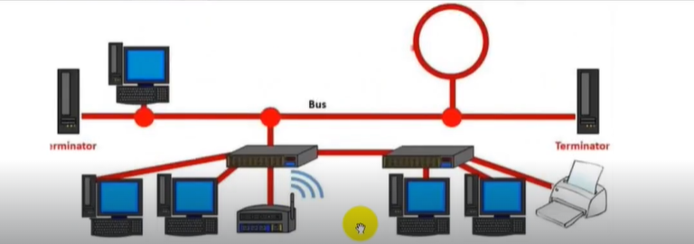Hybrid topology is mostly used to mix the wired network with the wireless network.

**Ring Topology:**

* In a ring topology, all computers are connected via cable that loops in a ring or circle.
* In ring topology each device is connected with the two devices on either side of it.
* In Ring Topology data moves down a one-way path from one computer to another.
* When data signals pass from one computer to next, each computer regenerates signals.
* Link failure can fail the entire network as the signal will not travel forward due to failure.

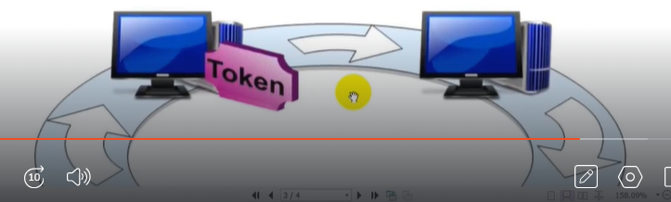

**Point-to-point Topology:**

* Point to Point topology is simplest topology connects two nodes directly.
* The Packets sent from one site are delivered to the other and vice versa.
* Point-to-point connections are used to connect LANs to service provider WANs.
* Entire bandwidth of common link is reserved for transmission between two nodes.
* Alternatively, it is also used to connect a node or computer directly to a switch.
* Connection between the switch and the computer is a real point-to-point connection.
* Point-to-point connections can be used to connect switches or routers to each other.

**Point-to-Multipoint Topology**

* This topology, end device connects directly to multiple end devices in the network
* In a multipoint connection, the link is between a sender and multiple receivers.
* A variation to the point-to-point topology is the point-to-multipoint topology.
* 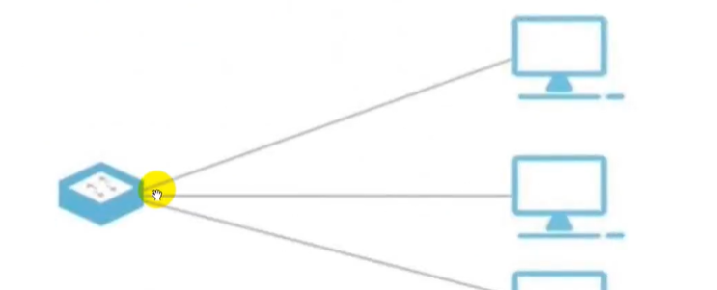Point-to-multipoint topology one device connecting to the multiple devices.